A PROJECT REPORT

on

“Demystifying DeepFake: A Beginner’s Guide To Understanding & Creating Digital Manipulation”

Submitted to

KIIT Deemed to be University

In Partial Fulfilment of the Requirement for the Award of

BACHELOR’S DEGREE IN

COMPUTER SCIENCE ENGINEERING

BY

AARSH SRIVASTAVA
ROLL NO- 20052007

UNDER THE GUIDANCE OF

DR. KRISHNANDU HAZRA
Assistant Professor (II), School of Computer Engineering
Kalinga Institute of Industrial Technology (KIIT)



SCHOOL OF COMPUTER ENGINEERING

KALINGA INSTITUTE OF INDUSTRIAL TECHNOLOGY

KIIT Deemed to be University

School of Computer Engineering
Bhubaneswar, ODISHA 751024

CERTIFICATE

This is certify that the project entitled

“Demistifying DeepFake: A Beginner’s Guide To Understanding & Creating Digital Manipulation“

submitted by

AARSH SRIVASTAVA
ROLL NO- 20052007

is a record of bonafide work carried out by them, in the partial fulfilment of the requirement for the award of Degree of Bachelor of Engineering (Computer Sci-ence & Engineering OR Information Technology) at KIIT Deemed to be university, Bhubaneswar. This work is done during year 2022-2023, under our guidance.

Date: 7 /26 /2023

(Guide Name)
DR. KRISHNANDU HAZRA
Assistant Professor (II), School of Computer Engineering
Kalinga Institute of Industrial Technology (KIIT)

ABSTRACT

Deepfake technology has emerged as a powerful tool capable of creating hyper-realistic digital manipulations, raising concerns about misinformation and potential threats to individual privacy and security. The project "Demystifying Deepfake: A Beginner's Guide to Understanding and Creating Convincing Digital Manipulations" aims to address these issues by providing an accessible and comprehensive resource for individuals seeking to understand the underlying concepts of deepfakes and learn how to create such content responsibly. The guide begins with an exploration of the fundamental concepts and literature review of deepfakes, elucidating the machine learning algorithms and data manipulation techniques involved. It identifies the problem statement by highlighting the ethical challenges posed by the misuse of this technology and outlines the project's requirements and objectives.

Throughout the project, careful planning and systematic analysis are conducted to develop an informative and well-structured guide. The system design section presents the guide's layout and organization, adhering to design constraints and industry standards. The implementation phase involves following a well-defined methodology and quality assurance measures to ensure the guide's reliability and accuracy. The testing and verification plan is employed to validate the guide's content, and the results are analyzed with supporting screenshots. The conclusion encapsulates the key insights, emphasizing the significance of understanding deepfake technology in today's digital landscape. Moreover, the future scope section suggests potential extensions and research avenues to tackle emerging challenges in the realm of deepfakes. This project ultimately serves as a foundational resource, empowering readers to navigate the complex world of deepfakes responsibly and contributing to a broader understanding of the technology's implications.

Keywords: Digital Manipulation, Deepfake, Machine Learning, Entertainment,
Misinformation.

Contents

1 | Introduction |  |  | 1
2 | Basic Concepts/ Literature Review |  |  | 2
 | 2.1 | Sub Section Name........................... |  | 2
3 | Problem Statement / Requirement Specifications |  |  | 3
 | 3.1 | Project Planning........................... |  | 3
 | 3.2 | Project Analysis (SRS)................. |  | 3
 | 3.3 | System Design ………………….. |  | 3
 |  | 3.3.1 | Design Constraints …… | 3
 |  | 3.3.2 | System Architecture (UML) / Block Diagram … | 3
4 | Implementation |  |  | 4
 | 4.1 | Methodology / Proposal ........................... |  | 4
 | 4.2 | Testing / Verification Plan ……………. |  | 4
 | 4.3 | Result Analysis / Screenshots …………. |  | 4
 | 4.4 | Quality Assurance …………………….. |  | 4
5 | Conclusion and Future Scope |  |  | 5
 | 5.1 | Conclusion ……………………….. |  | 5
 | 5.2 | Future Scope ………………………. |  | 5
References |  |  |  | 6

List of Figures

1.1 | IMAGE CAPTION ......................... | 2
4.1 | IMAGE CAPTION ......................... | 9

NAME OF PROJECT

Chapter 1

Introduction

The project entails a comprehensive literature review covering the fundamental concepts of deepfake creation, including data manipulation techniques and machine learning algorithms. It delves into the ethical implications surrounding deepfakes and addresses the need for public awareness and education.

Needs of the project:
Visual Effects and Entertainment Industry: Deepfake technology allows filmmakers and visual effects artists to create stunning and realistic special effects, digitally rejuvenate actors, or bring deceased actors back to the screen for storytelling purposes. It offers a cost-effective and time-efficient alternative to traditional CGI methods, enhancing the overall visual appeal of films and television shows.
Personalization and Customization: Deepfake technology enables the creation of personalized and customized content for users. This includes applications in virtual reality, augmented reality, and personalized marketing, where individuals can experience immersive and interactive content tailored to their preferences and interests.
Training and Simulation: Deepfakes find applications in training and simulation scenarios, particularly in industries like healthcare and defense. Simulated scenarios can help professionals, such as doctors or soldiers, practice critical procedures or tactical maneuvers without real-world consequences, leading to better skill development and preparedness.
Accessibility and Localization: Deepfakes can be used to dub videos or movies into different languages, making content more accessible to diverse audiences worldwide. It also allows for the creation of localized content, tailoring it to specific regions or cultures while retaining the original context and message.
Education and Research: In educational settings, deepfake technology can aid in creating interactive and engaging learning materials. It can bring historical figures to life, visualize complex concepts, or simulate real-life scenarios, enhancing students' understanding and retention of information.
Digital Content Creation and Editing: Content creators, influencers, and social media users can leverage deepfake technology for creative content generation, producing fun and entertaining videos or memes. It opens up possibilities for innovative storytelling and artistic expression.

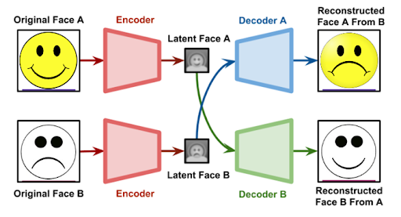

Figure 1.1: IMAGE CAPTION

School of Computer Engineering, KIIT, BBSR 1

NAME OF PROJECT

Chapter 2

Basic Concepts/ Literature Review

The literature review for the project "Demystifying Deepfake: A Beginner's Guide to Understanding and Creating Convincing Digital Manipulations" explores the fundamental concepts and background related to deepfake technology. It begins by providing an overview of deepfakes, which are synthetic media generated through advanced machine learning algorithms, such as Generative Adversarial Networks (GANs). These algorithms enable the manipulation of audio, video, and images to create hyper-realistic content that can be difficult to distinguish from genuine footage.
The review delves into the key components of deepfake creation, including data manipulation techniques and neural network architectures. It discusses the significance of large datasets for training deepfake models and the role of data pre-processing in enhancing the quality of generated content. Moreover, the review highlights the ethical implications of deepfakes, such as the potential for misinformation, identity theft, and privacy violations.
Furthermore, the literature review covers the various use cases and applications of deepfake technology, ranging from entertainment and art to more concerning instances of malicious intent, such as political disinformation campaigns and fake news propagation. The review also examines the current state-of-the-art methods and research advancements in detecting and mitigating deepfake content. It underscores the importance of public awareness and education to empower individuals to critically assess and identify deepfakes in today's digitally saturated environment. The literature review serves as a comprehensive foundation for readers, facilitating a deeper understanding of the concepts and complexities surrounding deepfake technology before delving into the practical aspects of creating convincing digital manipulations.

School of Computer Engineering, KIIT, BBSR 2

NAME OF PROJECT

Chapter 3

Problem Statement / Requirement Specifications

My goal was to create a deepfake video that would look same as of a video which is manipulated.

3.1 Project Planning

Before starting the project, a source video has to be created. I created the source video & gave my face for the training & desired manipulated result. & then plan was to go ahead with the deepface lab tutorials.

3.2 Project Analysis

Some more iterations were necessary & the most important thing- the source video had to be in alignment as of destination video especially the facial expressions in order to get desired result that could confuse people to find the real one.

3.3 System Design

3.3.1 Design Constraints

“DeepFaceLab_NVIDIA_up_to_RTX2080Ti” needs to be installed on any latest windows.

3.3.2 System Architecture OR Block Diagram

School of Computer Engineering, KIIT, BBSR 3

Chapter 4

Implementation

Implementation of the project was done using DeepFace Lab.

Steps Involved:

- Source & Destination videos at a place.
- Extract images from Source Video
- Extract images from destination Video
- Extract Faces from Source & Destination videos
- Training (Machine Learning)
- Merge (MP4)

Source & Destination videos at common place.

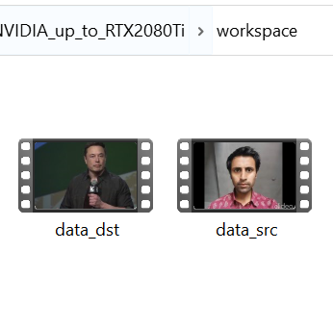

Extracting Images:
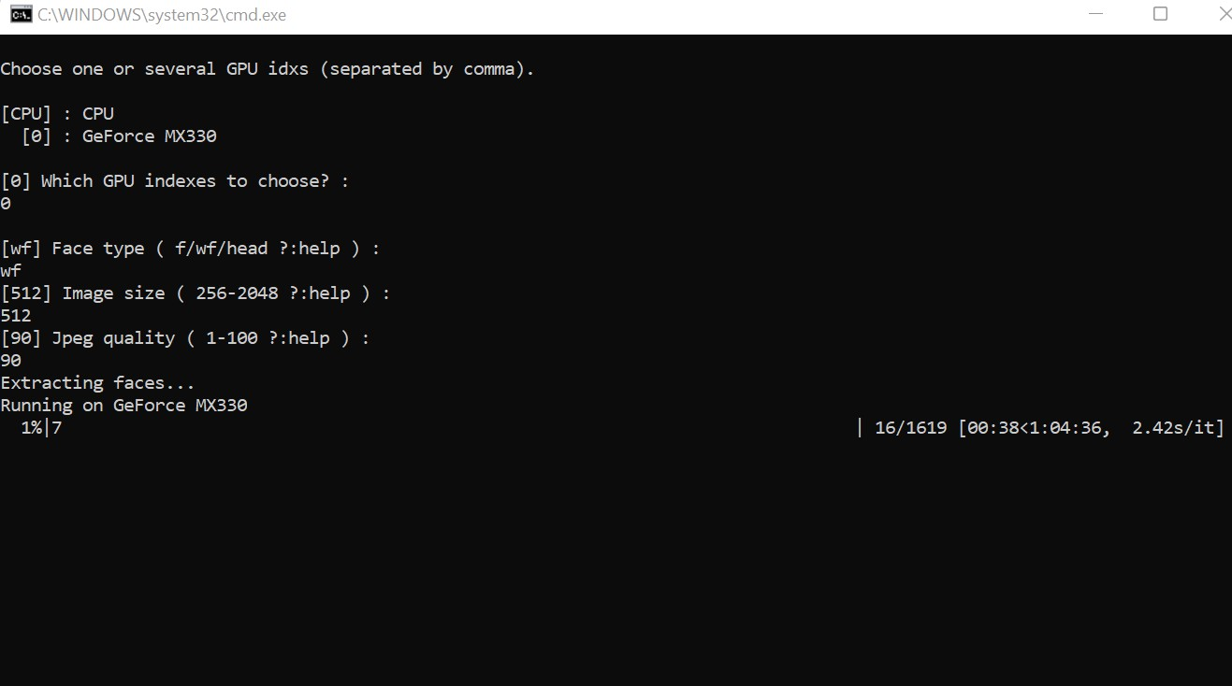

Training with help of Machine learning :

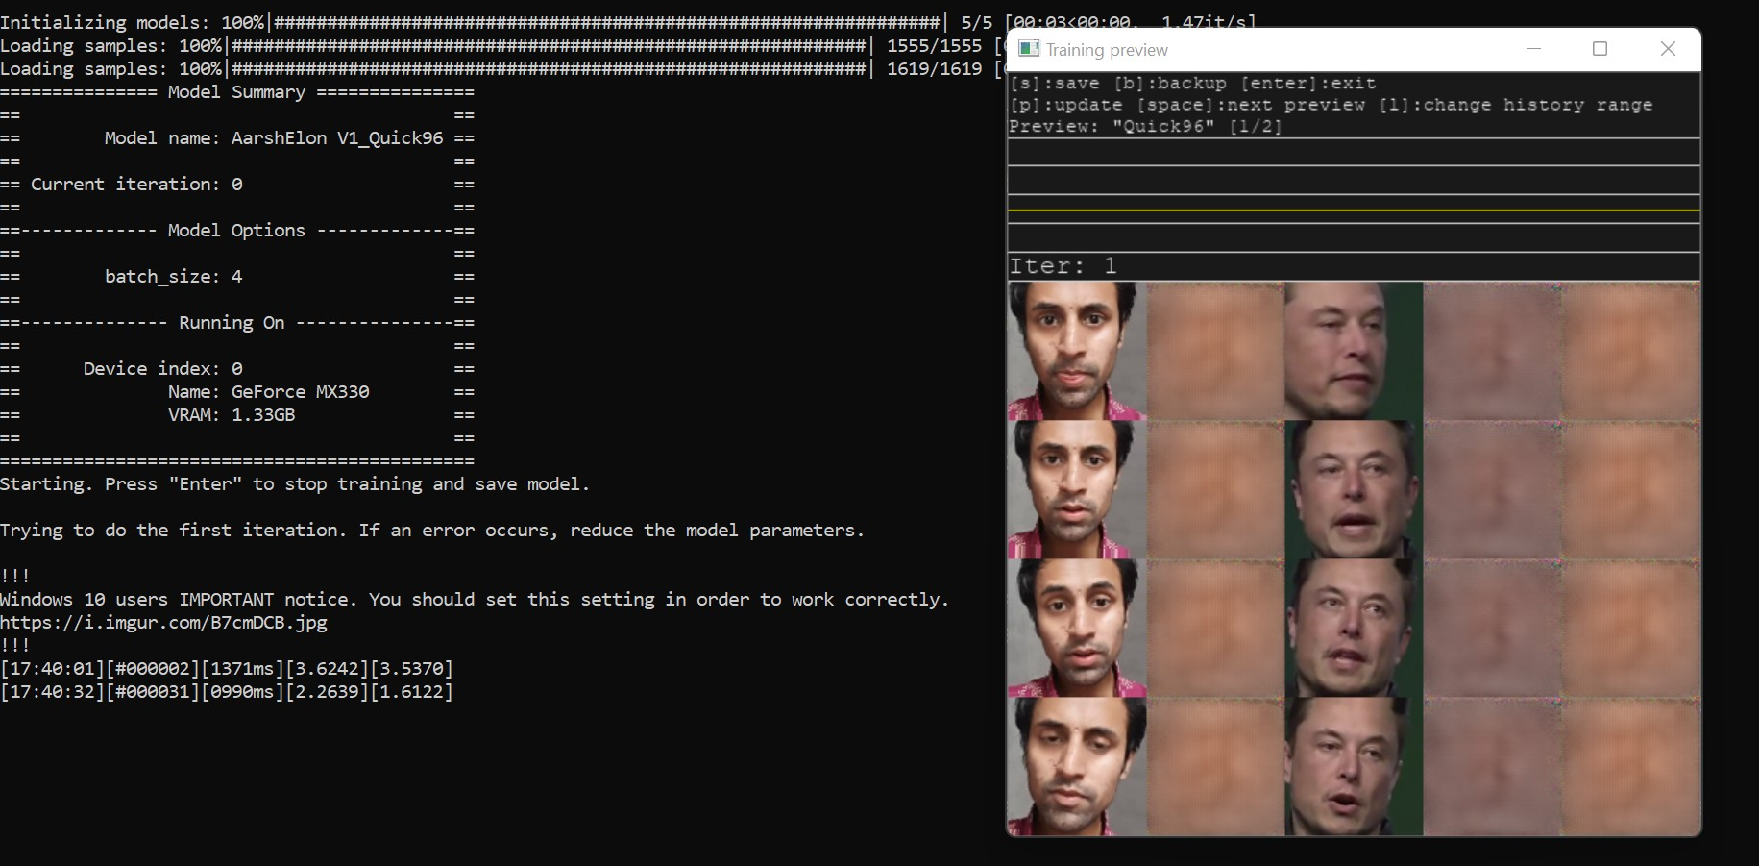

Iteration: 3515
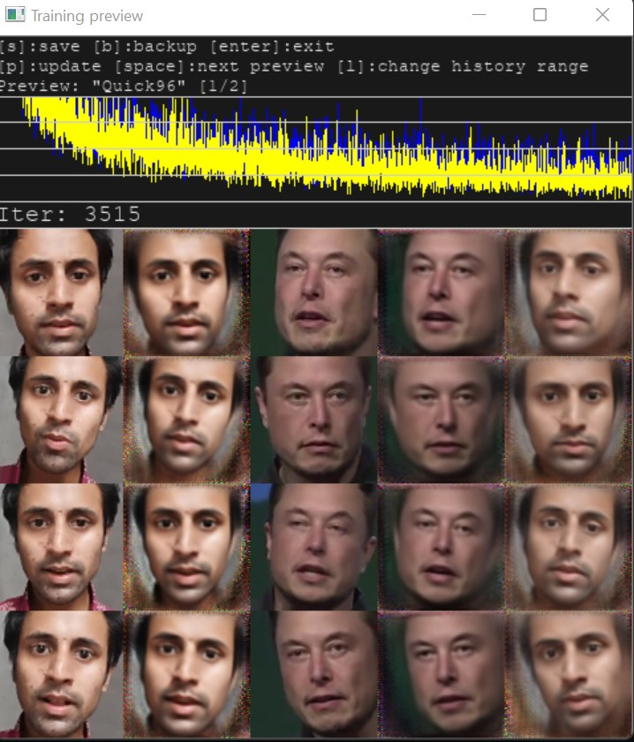
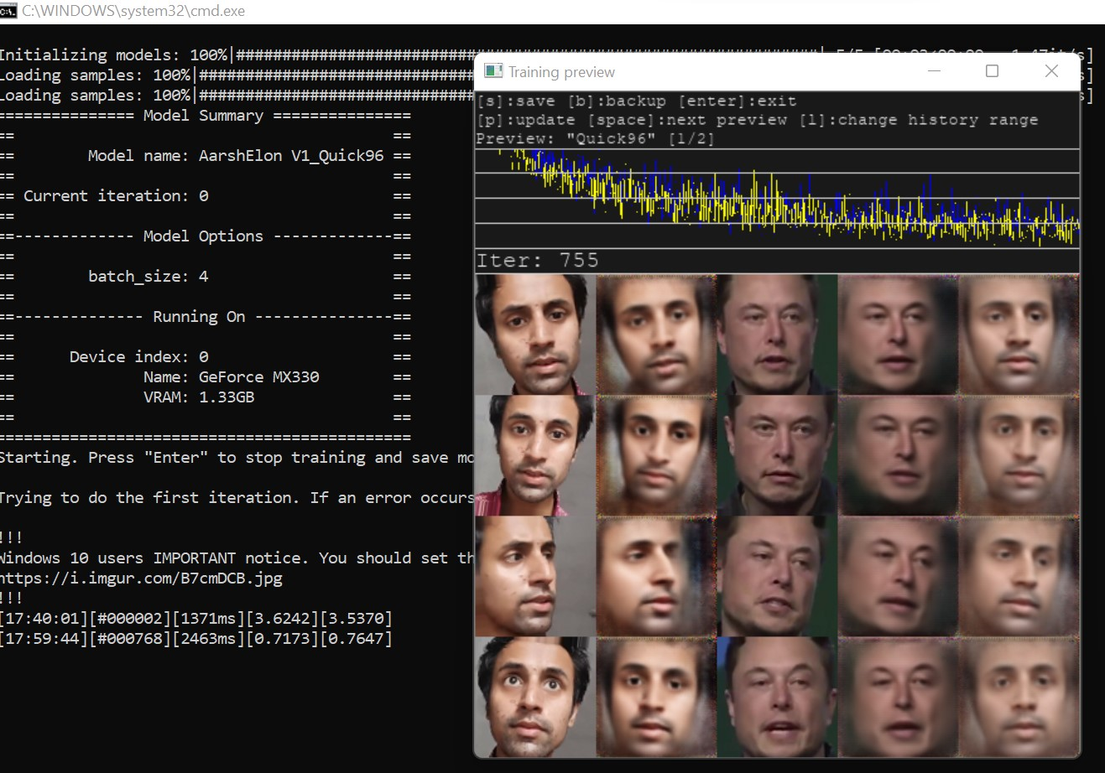

4.2 Testing OR Verification Plan

Once I felt the iterations were taking longer time & the trained outputs were coming a bit satisfactory, I decided to stop & save the training. The iterations were 6000 appx. When I stopped. After merging the trained outputs, the resultant video was observed by me. & I found that some more iterations were necessary & the most important thing- the source video had to be in alignment as of destination video especially the facial expressions in order to get desired result that could confuse people to find the real one.

4.3 Result Analysis OR Screenshots 

4.4 Quality Assurance

Since this is a Machine learning project where model learns through training. The more the training(Iterations), the better the result.

School of Computer Engineering, KIIT, BBSR 4

NAME OF PROJECT

Chapter 6

Conclusion and Future Scope

6.1 Conclusion

Deepfake technology is a powerful tool that has the potential to transform the way we create and consume media. However, it is important to approach this technology with caution and consider its potential implications. With the right safeguards in place, deepfake technology can be a force for good in our society

6.2 Future Scope

Deepfake technology has the potential to revolutionize the entertainment industry and create new opportunities for artistic expression. However, it also has the potential to be used for malicious purposes, such as political propaganda or fraud. As the technology continues to evolve, it is important to consider its ethical implications and develop strategies for detecting and preventing its misuse. Deepfake technology has the potential to revolutionize the entertainment industry and create new opportunities for artistic expression. However, it also has the potential to be used for malicious purposes, such as political propaganda or fraud. As the technology continues to evolve, it is important to consider its ethical implications and develop strategies for detecting and preventing its misuse.

References

Deepfake tutorial & Explaination, Murtaza’s work (Youtube Channel)

Deepfake Theory & Thesis , Source Google.

School of Computer Engineering, KIIT, BBSR 7

Full Signature of Supervisor: Full signature of the student:

Aarsh Srivastava

……………………………. ……………………………..

School of Computer Engineering, KIIT, BBSR 8

